**Background**

The effects of sleep deprivation on individuals' normal neurological function is an area that has extensive research. Many studies and researchers suggest that Sleep Deprivation (SD) is a complex issue that may cause deficits in multiple brain areas and behaviours. The effects of SD can impact areas including attention, decision-making, behaviour, and memory. Unsurprisingly, university students are one of the groups known to report the highest levels of insufficient sleep, even though they spend most of their time using vast cognitive resources to study. In other words, although university students report the highest levels of SD, they might be the most negatively affected by it. Consequently, it is vital to understand the deficits and impairments that arise from SD so students are aware of the importance of prioritizing sleep in their busy schedules.

Mao and Colleagues (2023) conducted a study investigating how SD impacts risky decision-making at the neural level. Their findings suggest that “participants' risk-induced activation…negatively correlated with risk-taking propensity…suggesting that sleep loss may impair brain-behaviour associations and neural responses to decision outcomes” (8). In other words, Mao and Colleagues provide evidence that supports the theory that SD can lead to impaired behaviours and risky decision-making. However, it is essential to note that the length of SD was a limitation in this study, and further research should be conducted to see the effects of long-term SD.

Furthermore, another study by Huang and Colleagues (2009) investigated how SD impairs neural signalling in the hippocampus. They believed “The fact that sleep deprivation does not affect this form of LTP suggests that brief sleep deprivation does not generally disrupt translational processes, but instead specifically alters mechanisms that depend upon cAMP/PKA signalling” (p. 2). So, they found that a rare occurrence of SD does not have the same effect as long term SD. The overall results of their study demonstrate that “the hippocampus is an integral part to context-specific memory and highly dependent upon hippocampal function, and the researchers found that sleep deprivation significantly impaired this type of memory” (3).

Additionally, Xu and Colleagues (2023) conducted a study investigating the restoration ability (specifically short nap intervals) after sleep deprivation on cognitive function. This study concluded that “after SD, sleepiness leads to dysconnectivity in the DM and CC and between the DM and CC networks, which in turn causes cognitive deficits” (p. 7). Also, Xu and Colleagues found that “after SD, sleepiness leads to dysconnectivity in the DM and CC and between the DM and CC networks, which in turn causes cognitive deficits” (p. 7). Overall, the findings of this study suggest that SD causes dysconnectivity in the DMN, leading to cognitive impairment. These deficits are best treated with shorter interval naps than long-interval naps. A study by Li and Colleagues (2023) investigated the role of astrocytes in sleep deprivation, specifically, how a specific receptor (PirB) may help regulate the reactiveness in astrocytes that cause SD. They found that “PirB overexpression decreased the number of neurotoxic astrocytes, enhanced synapse formation, and improved neurological function, whereas PirB depletion resulted in more extensive neuronal damage” (p. 11). In other words, PirB depletion caused the astrocytes to become more reactive, leading to SD and, therefore, cognitive impairments. Furthermore, their findings “indicated that PirB overexpression in astrocytes improves cognitive function in mice after SD” (p. 11). The researchers could conclude that PirB helps regulate these reactive astrocytes and can also aid in restoring cognitive function after SD.

A study by Pesoli and colleagues (2022) investigated how 24 hours of sleep deprivation affects topology and cognitive functioning. Using task-switching (TS) and sequential letter cancellation (LC), MEG Pesoli and colleagues determined that SD affects cognition amongst men in their early twenties. The sleeping brain is highly cholinergic; specifically, “Cholinergic tone is known to be modulated by wakefulness via the inhibition induced by adenosine (AD) on acetylcholine (ACh)” (p. 52). SD causes AD levels to increase, which then causes changes in the cholinergic system, starting at the basal forebrain to control selective visual attention through the subcortical and cortical regions of the brain. The research found that participants completed TS faster after 24 hours of SD but executed LC more poorly after SD. These results suggest that SD affects top-down-driven selective attention more than bottom-up. However, the study predicts that quicker TS performance could have been due to frustration-motivated performance rather than SD. The conclusions made by Pesoli and colleagues align with the prediction that SD negatively impacts the functioning of cognitive tasks. Moreover, the study only included young men. It is helpful to have specific information for that age and gender; it limits how informative or accurate the results would be compared to other ages and genders. Another limitation of this study is its lack of research on the long-term effects of SD on cognitive functioning.

The previous articles prove that SD has a cascade of effects on cognition and neuronal function. However, the articles discussed above investigate how SD is *caused* and the resulting deficits, whereas we are more focused on how sleep deprivation *affects* normal neurological function. Our research study aims to discover what neurological deficits arise from SD—specifically attention, behaviour, and decision-making. Sleep deprivation (SD) is common, especially among university students, where many sacrifice sleep for studying and finishing assignments on time. However, could this be doing more harm than good? The studies discussed above indicate *yes*. Beyond feeling fatigued after SD, many impairments and deficits severely affect cognitive function. These impairments include impaired hippocampal function, reduction in neuronal signalling, and increased risk-taking. This is significant in our research, as it provides evidence that an individual's typical neurological functioning may become severely impaired by SD and argues that one of the most critical factors a University student should prioritize is *sleep.*

**Research Question (can/will be modified to fit better around the entire paper)**:

This study examines how sleep affects daily brain function—specifically, the relationship between sleep deprivation and inhibiting neurological or cognitive function among post-secondary students.

BRIEF OVERVIEW OF OVERALL METHODICAL DESIGN

To answer our research question, we used convenience sampling to select a sample of undergraduate students from the University of British Columbia-Okanagan Campus(UBCO) student population. It was important to have a sample of essentially sleep-deprived participants. Therefore, before being selected for our study, we had participants sign an informed consent form that asked them to agree to fill out a survey regarding the amount of sleep they got each night. In an attempt to fill in the gaps made in other studies, we looked at the impact of long-term sleep deprivation on neurological function compared to short-term sleep deprivation in this study. We define long-term sleep deprivation (SD) as someone who has not slept adequately for at least three months. After obtaining our sample and survey results, participants were monitored with actigraphy and sleep-wake diaries at home. From this information, we split the participants into two groups. Group 1 consisted of those participants who had experienced sleep deprivation for less than three months (short-term SD). Group 2 were the participants who had been experiencing sleep deprivation for more than three months (long-term SD). In order to ensure none of our participants had sleep disorders, a night of polysomnography and oximetry measurements were conducted in the laboratory. In the laboratory, both groups participated in two fMRI sessions during an 8-day study with seven nights of sleep. One of the scan sessions was after one night of rested wakefulness, and one was performed after a 24-hour total sleep deprivation. For four consecutive days, participants in each group were instructed to perform various behaviour tasks, including memory, attention, and decision-making tasks. Scores were collected. Participants were also compensated for this study.

Hypothesis

We propose that sleep deprivation in university students will significantly disrupt cognitive abilities, particularly in decision-making and memory. This disruption is expected to manifest as observable changes in brain activity, notably in the frontal and parietal lobes, as detected by fMRI. Furthermore, we anticipate that these cognitive deficits will be associated with alterations in the brain's connectivity, especially within the default mode network, observable through changes in resting-state functional connectivity. This study aims to uncover the underlying neurological mechanisms of sleep deprivation's impact on the cognitive functions of academically engaged young adults.

Significance

For a brief overview, studies suggest that sleep deprivation (SD) leads to cognitive impairments, specifically impaired hippocampus activity and reduced neural signaling that leads to attention span decrease and risky decision making. Using TS and LC, the results of Pesoli et al. suggest that SD affects top-down-driven selective attention more than bottom-up. However, the study also predicts that faster TS might be due to frustration-motivated performance rather than being affected by SD. Therefore, further research on such would help because if SD is the one affecting cognitive performances rather than frustration-motivated performance, male university students are directly affected if SD is common. The participants were only young male, but predictions of its effect on females should remain the same. In addition, the study’s lack of research on the negative impact of cognitive functioning caused by long term SD shows how short term SD is already enough to negatively affect normal cognitive tasks.

The significance of this study varies from the hypothesized causes and correlations of factors that affect SD, to the treatments that might help. As post secondary students need more time for studying, SD becomes a common problem. This present study holds significance implications for the field of psychology, as it addresses problems on SD and its effect on specifically post secondary students. By employing research methodologies and literature review on such topic, we end with possible future investigations and implications. For example, academic performances, mental health, and safety concerns are all potential continuations of the topic. As studies suggest SD being closely correlated with impaired cognitive functions, attention span, and also memory consolidation, the study may suggest that post secondary students with SD face challenges on academic performances, this include and does not limit to: lectures, information retaining, and essentially overall performances. Furthermore, as SD is also closely linked to risky decisioning and mental health states, this study may help in improving campus security and support services.

In summary, the effects of SD on post secondary students have direct implications for academic performances, cognitive performances, risky decision making, and safety measure concerns. These support development on support and interventions to help students.

FIGURE OF DATA

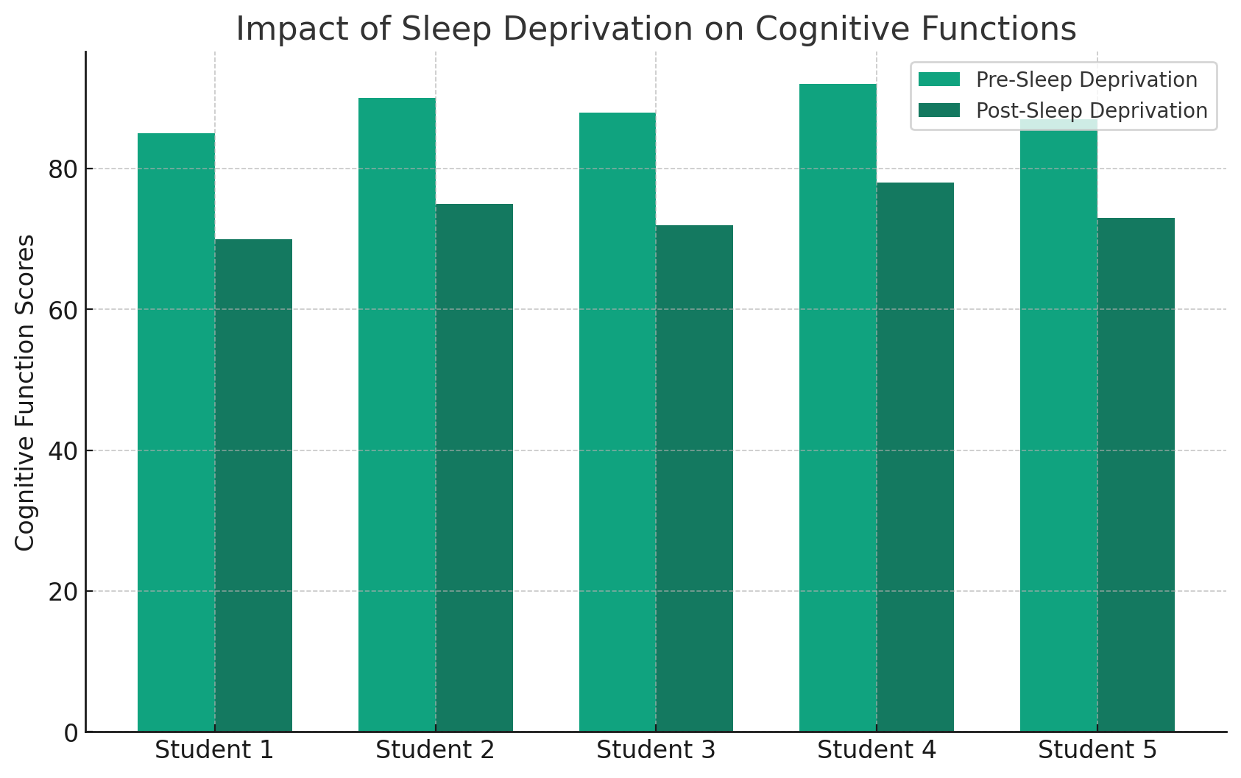

Our graph presents expected outcomes based on our study of sleep deprivation's effect on student cognition. It shows a before-and-after comparison of cognitive scores among university students, highlighting a predicted decline post-deprivation. This trend reflects potential cognitive impairments, like weaker decision-making and memory recall, due to lack of sleep. The X-axis indicates individual students, and the Y-axis their cognitive scores, providing a clear visual of how sleep deprivation might affect students' cognitive abilities. The "Cognitive Function Score" in your study is a composite measure derived from cognitive tests, assessing memory recall, decision-making, attention, problem-solving, and executive functioning. These elements are evaluated using standardized tests, and their scores are combined to reflect a student's cognitive performance. This metric is pivotal in comparing cognitive abilities before and after sleep deprivation in your research.